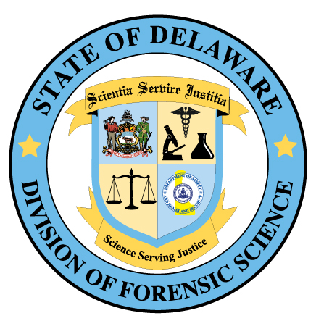

JOB TITLE: CHIEF FORENSIC INVESTIGATOR
RECRUITMENT # 032320-MBAB03-450100
CLOSING DATE: 4/21/20
To view full posting details about this position and to apply, go to www.delaware.statejobs.gov

Job Summary: The incumbent conducts forensic death investigations and supervises forensic investigators statewide. Duties include but are not limited to: death scene investigations and reporting, lifting and transporting bodies and interacting professionally with law enforcement, medical facilities and agencies, private physicians and family members. The incumbent performs administrative and human resources related functions. Work schedule includes day and evening shift hours with some overnight/weekend on-call coverage.
JOB REQUIREMENTS for Chief Forensic Investigator
Applicants must have education, training and/or experience demonstrating competence in each of the following areas:
- Three years experience in planning, developing, coordinating and implementing forensic investigations.
- Three years experience in determining compliance with laws, rules, regulations, standards, policies and procedures.
- Six months experience in forensic photography which includes scene, autopsy, and macro imaging documentation as well as awareness of legal developments relating to digital and multimedia evidence.
- Six months experience in civil, criminal or administrative proceedings.
- Six months experience in providing testimony before boards, commissions, administrative bodies or court officials.
- Six months experience in narrative report writing.
- Knowledge of staff supervision acquired through course work, academic training, training provided through an employer, or performing as a lead worker overseeing the work of others; OR supervising staff which may include planning, assigning, reviewing, and evaluating the work of others; OR supervising through subordinate supervisors a group of professional, technical, and clerical employees.
- Possession of a valid Driver’s License (not revoked, cancelled or suspended).
PREFERRED QUALIFICATION: Applicants who do not possess the preferred qualification will still be eligible to compete for this position if job requirements are met.
- Possession of an American Board of Medicolegal Death Investigation (ABMDI) certificate
CONDITION OF HIRE: A satisfactory background check (including a fingerprint based background check administered by the Delaware State Police) is required as a Condition of Hire. The selected candidate will be required to submit a buccal swab for DNA upon employment and subjected to randomized drug testing during the term of their employment.

